**Project Design Phase-II**

**Technology Stack (Architecture & Stack)**

|  |  |
| --- | --- |
| Date | 15 October 2022 |
| Team ID | PNT2022TMID33851 |
| Project Name | Project - xxx |
| Maximum Marks | 4 Marks |

**Technical Architecture:**

The Deliverable shall include the architectural diagram as below and the information as per the table1 & table 2

**Example: Order processing during pandemics for offline mode**

**Reference:** [**https://developer.ibm.com/patterns/ai-powered-backend-system-for-order-processing-during-pandemics/**](https://developer.ibm.com/patterns/ai-powered-backend-system-for-order-processing-during-pandemics/)

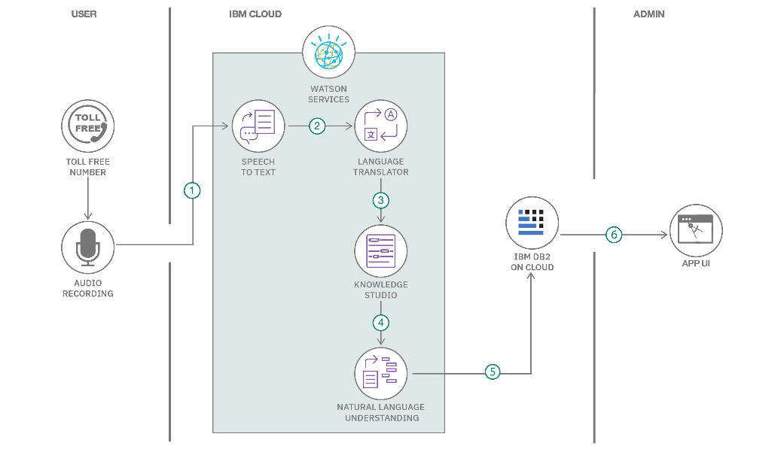

Guidelines:

1. Include all the processes (As an application logic / Technology Block)

2. Provide infrastructural demarcation (Local / Cloud)

3. Indicate external interfaces (third party API’s etc.)

4. Indicate Data Storage components / services

5. Indicate interface to machine learning models (if applicable)

**Table-1 : Components & Technologies:**

|  |  |  |  |
| --- | --- | --- | --- |
| S.No | Component | Description | Technology |
| 1. | User Interface | How user interacts with application | RFID,NFC,LTE – A, Low Energy Radio Protocols, Raspberry Pi, Rocket chat |
| 2. | Application Logic-1 | Logic for a process in the application | MIT App Inventor |
| 3. | Application Logic-2 | Logic for a process in the application | Ai2. App Companion |
| 4. | Cloud Database | Database Service on Cloud | IBM cloudant |
| 5. | File Storage | File storage requirements | IBM Block Storage or Other Storage  Service or Local Filesystem |
| 6. | External API-1 | Purpose of External API used in the application | Speech to text recognition Application |
| 7. | Infrastructure (Server / Cloud) | Application Deployment on Local System / Cloud  Local Server Configuration:  Cloud Server Configuration : | Local, Kubernetes, etc. |

**Table-2: Application Characteristics:**

|  |  |  |  |
| --- | --- | --- | --- |
| S.No | Characteristics | Description | Technology |
| 1. | Open-Source Frameworks | List the open-source frameworks used | Technology of Opensource framework |
| 2. | Scalable Architecture | Justify the scalability of architecture (3 – tier,  Micro-services) | Technology used |
| 3. | Availability | Justify the availability of application | Technology used |
| 4. | Performance | Design consideration for the performance of the  application | Technology used |

**References:**

**https://c4model.com/**

**https://www.ibm.com/cloud/architecture**

**https://medium.com/the-internal-startup/how-to-draw-useful-technical-architecture-diagrams-2d20c9fda90d**